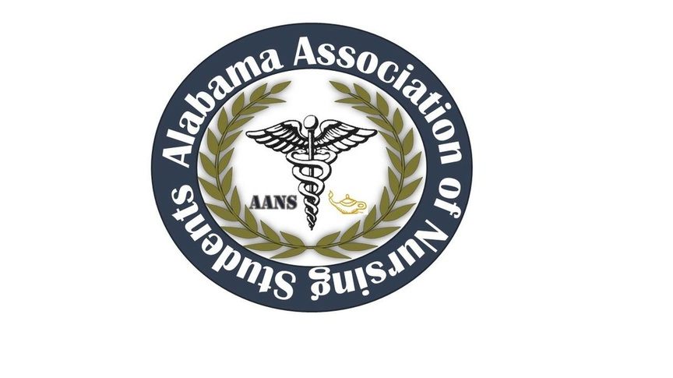
ALABAMA ASSOCIATION OF NURSING STUDENTS (AANS)
-Executive Board Meeting Conference Call-
– July 21st, 2016-
Call to order: Heather Burnette, President
The July 2016 meeting of the Alabama Association of Nursing Students was called to order on 07/21/2016 at 1939 by Heather Burnette, President.
Roll Call: Candice Sanders, Secretary 1939
- Heather Burnette, President
- Emily Walters, Vice President
- Candice Sanders, Secretary
- Katie Kaye, Communications Director
- Amber Hood, Community Health Director
- Mark Reynolds, Faculty Advisor
- Colin Tomblin, State Consultant

Those found not to be in attendance were as follows:
- Destiny LaBo, Treasurer
- Ashlyn Sharp, Director North and South
- Betsey Poole, Legislative Chair

Heather Burnette also introduced our upcoming AANS faculty advisor Mrs. Donna Guerra. She will be listening in on our phone conference to help facilitate new AANS officers. Heather Burnette moved to adopt the June 2016 meeting minutes at 1942. Emily Walters seconded this motion. No objections were made.
Heather Burnette, President
Heather Burnette moved to adopt The Candidate and Campaigning Rules for 2016-2017 Board of Directors elections at 1944. Katie Kate seconded this motion. No objections were made.
Convention Planning
- Speakers
- 3 spots are available for convention.
- Rough draft of speakers is attached.
- Vendors
- Vendor List and letter are available. Be sure to use our vendor sheet with the AANS logo.
- Sponsors
- We are asking our sponsers for small goody bags and door prizes. Continue to work on getting more vendors.
- Donations thus far
- Marcy Reynolds – Mary Kay basket for auction
- Needs AANS label to ensure credit is given
- ASNA – Brian Buchmann
- Each district in Alabama gave $400 for student meals for a total of $2,000 donated.
- Heather Burnette motioned that gift cards of $10 per card for meals will be given to students. This will equal a total of 200 cards. Amber Hood seconded the motion. There were no objections.
- Brian Burchman is working on getting 150Huntsville Hospital lanyards for our goody bags.
- Awards Banquet
- Ashlyn Shapr will be in charge of our Awards Banquet this year. It will be held on Friday evening from 5:30-6:00. The Awards packets have been updated and currently on the website.
- T-shirts
- The vote between Gildan and Comfort Colors for the t-shirt brand was a tie. Mark Reynolds agreed to break the tie for Comfort Colors brand at $9.25 (s-xl) and $11.25 (2xl) each.
- Heather Burnette motioned for the t-shirt brand to be Comfort Color at the price of $9.25 (s-xl) and $11.25 (2xl) each. Candice Sanders seconded the motion and no objections were made.
- The shirt color was also a tie between red, blue and gray.
- Design color
- After discussion, Heather Burnette motioned for there to be both red shirts and blue shirts with white writing. This also includes a $10 screen color change fee. Amber Hood seconded this motion.
- After discussion, Heather Burnette motioned for 100 red white and 100 blue shirts. Katie Kaye seconded this motion. There were no objections.
- Convention Budget:
- Snacks for goodie bags
- T-shirts
- Speaker gifts
- Rooms
- Meals, including transition meeting
Vice President – Emily Walters
- Emily Walters is currently working on recruiting more vendors.

Communications Director – Katie Kaye
- Website is currently up to date on awards packet and convention information.
- The email blasts has also been repurchased to continue to keep our students and advisors up to date with AANS information.

Meeting adjournment as of 2031

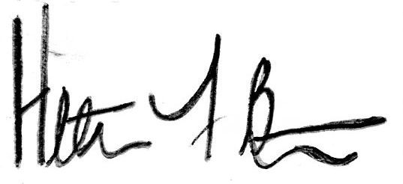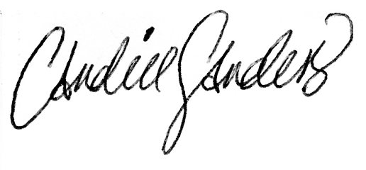
Heather Burnette, President Candice Sanders, Secretary

July 28th, 2016
Via Survey Monkey, the majority voted to keep the ticket prices the same as last year. No objections were made.

