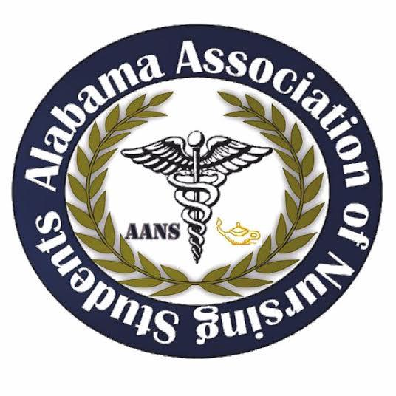

Alabama Association of Nursing Students
Executive Board Meeting, November 10, 2019
Conference Call

1. Call to Order: The monthly meeting of the Executive Board was called to order at 1600 by Tiffany Tucker, President.

2. Roll Call: Called by Christopher Leone, Secretary.

Those Present:
President – Tiffany Tucker
Vice President – Anna Beth Franks
Secretary – Christopher Leone
Treasurer – Candice Davis
Communications Director – Kassydi Spurgeon
Breakthrough to Nursing Director – Tonja Grace
Community Health Director – Stahler Heath
Legislative Chair – Landon Nichols
Director of North – Laura Bowman
Director of South – MaKayla Davis

Those Absent: none

Quorum: Tiffany Tucker, President, declared a quorum present.

3. Minutes: The minutes from the October 6, 2019 Executive Board Meeting were distributed and read.

Motion: It was moved and seconded to accept the minutes of the October 6, 2019 Executive Board Meeting.
Submitted by: Tiffany Tucker, President. Seconded by: Laura Bowman. No objections made. Action: Carried.

4. Report of the Treasurer: The report was given by Candice Davis and a written report was distributed and is attached to the minutes. Highlights of the report included:
a) Account balance: Checking account $38,419.61 ; Savings account: none. Reserve investment account: none.
b) Outstanding bills: __
c) The budget for this year: $_

Motion: It was moved and seconded to accept the report of the treasurer.
Submitted by: Tiffany Tucker. Seconded by: Stahler Heath. No objections made. Action: Carried.

5. Reports from officers and committee chairs:

- President – Tiffany Tucker
- Attended MidYear: COSP
- Ideas to boost membership
  - Member could speak at their local chapters, and others in area
  - Currently making powerpoints for presentations
- Call for Abstracts has been sent. 2 unofficial responses have been met with.
- Working on logo for Leadership Summit, all suggestions welcome
- Vice President – Anna Beth Franks
- Attended MidYear: COSP
- We are able to access AANS emails to advertise for leadership summit
- Secretary – Chris Leone
- Be sure to stay on top of sending information if needed
- Treasurer – Candice Davis
- Gained access to account November 6, 2019
- Money market account
- Scholarship opportunities for students. Details of initiating it will be discussed and finalized on prior to starting it.
- Communications Director – Kassydi Spurgeon
- Posted about Nurses Day at the Capitol
- Updated board on AANS website
- Posted about scholarships
- Secured a feature in the upcoming print of national newsletter
- New email addresses are being considered to improve security
- Community Health Director – Stahler Heath
- Project idea: Medcaid. Meant to increase awareness of Medicaid with children and disabled populations.
- Director of North – Laura Bowman
- Updating email contact list for current SNAs
- Need contact info for Bevill State
- Unable to find contact info on Herzing University
- Director of South – MaKayla Davis
- A list of different schools has been made.
- Legislative Chair – Landon Nichols
- Attended planning meeting for Nurses Day at the Capitol.
  - We have a spot to speak.
- Breakthrough to Nursing Director – Tonja Grace
- Calhoun will be bringing a cohort of 75-100 students to next summit.

6. Unfinished Business:
- Leadership Summit will be from 0830-1500, Feb 29th
- Ticket price $35
  - Tiffany Tucker moved to change price of early bird and groups of 20 or more to $30
- Food for AANS Leadership Summit:
  - Ms. Mobley’s family caterer
  - Sweet Peppers

- Speakers: we need to decide on how many speakers we are going to have
  - Full day: 6-8 speakers
- Sponsors
  - Each board member needs to contact a potential sponsor
  - Sponsor Levels: what amounts do we want to preset?
    - Platinum
      - Name/Logo featured on event material
      - Name/Logo featured on screen
      - Recognition on website and facebook
      - Recognition during speech
    - Gold
      - Name/Logo featured on event material
      - Name/Logo featured on screen
      - Recognition on website and facebook
      - Recognition during speech
    - Silver
      - Name/Logo featured on event material
      - Recognition on facebook
      - Name/Logo featured on screen
    - Bronze
      - Name/Logo featured on screen

Motion: It was moved and seconded to have sponsor levels at the AANS Leadership Summit.
Submitted by: Tiffany Tucker. Seconded by: _. No objections made. Action: Carried.

- Hurst has been secured and will provide new questions
- Potential speakers
  - Faculty

- Potential sponsors
  - Banks
  - Hospitals

- Faculty abstracts topic: Clinical decision making

7. New Business:
- Leadership Summit ticket price $35
- Money market account
- Scholarship requirements
- T-Shirts and sponsorships will be researched and discussed.
- Sponsorship increments will be finalized at next meeting

8. Next Meeting: The next meeting set for December 15, 2019 at 1600.

9. Announcements: No announcements.

10. Adjournment: Tiffany Tucker, President, has declared the meeting of the executive board to be adjourned at 1731 and will reconvene December 15th, 2019 at 1600

Tiffany Tucker, President Chris Leone, Secretary 