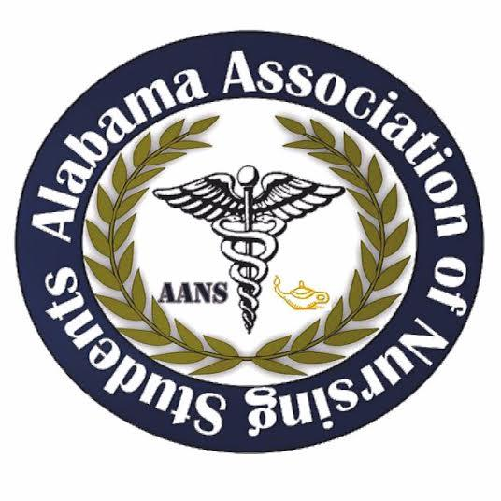

Alabama Association of Nursing Students
Executive Board Meeting, December 15, 2019
Conference Call

1. Call to Order: The monthly meeting of the Executive Board was called to order at 1603 by Tiffany Tucker, President.

2. Roll Call: Called by Christopher Leone, Secretary.

Those Present:
President – Tiffany Tucker
Vice President – Anna Beth Franks
Secretary – Christopher Leone
Treasurer – Candice Davis
Communications Director – Kassydi Spurgeon
Community Health Director – Stahler Heath
Director of North – Laura Bowman
Director of South – MaKayla Davis

Those Absent:
Breakthrough to Nursing Director – Tonja Grace
Legislative Chair – Landon Nichols

Quorum: Tiffany Tucker, President, declared a quorum present.

3. Minutes: The minutes from the October 6, 2019 Executive Board Meeting were distributed and read.

Motion: It was moved and seconded to accept the minutes of the October 6, 2019 Executive Board Meeting.
Submitted by: Tiffany Tucker, President. Seconded by: Laura Bowman. No objections made. Action: Carried.

4. Report of the Treasurer: The report was given by Candice Davis and a written report was distributed and is attached to the minutes. Highlights of the report included:
a) Account balance: Checking account $40,369.61; Savings account: none. Reserve investment account: none.
b) Outstanding bills: none
c) The budget for this year: TBD

Motion: It was moved and seconded to accept the report of the treasurer.
Submitted by: Tiffany Tucker. Seconded by: Stahler Heath. No objections made. Action: Carried.

5. Reports from officers and committee chairs:

- President – Tiffany Tucker
- NetCE will send items for Leadership Summit
- Abstract update – 3 for faculty and 2 for students. Potentially more to be included.
- Vice President – Anna Beth Franks
- Have been working on t-shirt design. Ideas are wanted, contact Anna Beth with them.
- Secretary – Chris Leone
- Contact if you need minutes or topics from last meetings.
- Send minutes and talking points to me prior to me if possible.
- Treasurer – Candice Davis
- Has talked with faculty at Beville State about potential abstracts
- Communications Director – Kassydi Spurgeon
- Website will keep staying upated.
- Community Health Director – Stahler Heath
- Nothing to report
- Director of North – Laura Bowman
- Contact list is finished.
- Director of South – MaKayla Davis
- Not all colleges have nursing programs, the ones that don’t have been dropped from contact list.
- Legislative Chair – Landon Nichols

- Breakthrough to Nursing Director – Tonja Grace

6. Unfinished Business:
- Scholarships

Motion: It was moved and motioned to set the scholarship price at $2,5000.
Submitted by: Tiffany Tucker. Seconded by: Candice Davis
No objections made

- Summit
  - Ticket price $35
  - Food for AANS Leadership Summit:
    - Southern Mix Catering Company
    - Sweet Peppers
- Money Market account

7. New Business:
- ASNA has encouraged us to submit articles for Alabama Nurse. Has to be completed by January 2nd.
- Responsibilities for next meeting pertaining to Leadership Summit will be emailed within the next week.
- Issues of Alabama Nurse can be downloaded from ASNA website.

8. Next Meeting: The next meeting set for January 12th at 1600.

9. Announcements: Issues of Alabama Nurse can be downloaded from ASNA website.

10. Adjournment: Tiffany Tucker, President, has declared the meeting of the executive board to be adjourned at 1627 and will reconvene January 12th, 2019 at 1600

Tiffany Tucker, President Chris Leone, Secretary 