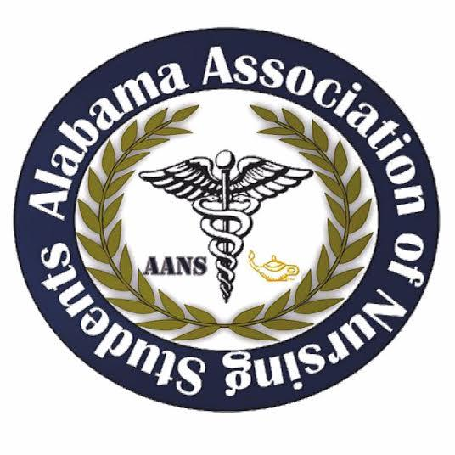

Alabama Association of Nursing Students
Executive Board Meeting, January 12, 2020
Conference Call

1. Call to Order: The monthly meeting of the Executive Board was called to order at 1602 by Tiffany Tucker, President.

2. Roll Call: Called by Tiffany Tucker, President.

Those Present:
President – Tiffany Tucker
Vice President – Anna Beth Franks
Treasurer – Candice Davis
Community Health Director – Stahler Heath
Director of North – Laura Bowman
Director of South – MaKayla Davis

Those Absent:
Communications Director – Kassydi Spurgeon
Legislative Chair – Landon Nichols

Quorum: Tiffany Tucker, President, declared a quorum present.

3. Minutes: The minutes from the December 15, 2019 Executive Board Meeting were distributed and read.

4. Report of the Treasurer: The report was given by Candice Davis and a written report was distributed and is attached to the minutes. Highlights of the report included:
a) Account balance: Checking account $ 40,959.61; Savings account: none. Reserve investment account: none.
b) Outstanding bills: none
c) The budget for this year: TBD

Motion: It was moved and seconded to accept the report of the treasurer.
Submitted by: Tiffany Tucker. Seconded by: Makayla Davis. No objections made. Action: Carried.

5. Reports from officers and committee chairs:
- President – Tiffany Tucker
- Contacted: Parkway Scrubs, UWorld, Hurst
- Abstract update: 7 submission; 6 faculty track
- Flyer created
- Vice President – Anna Beth Franks
- T-shirts: Jim Fiscus at T-Shirts N Moore Customer Printing
- Contacted sponsors: Uniform Corner, Berney Office Solutions
- Treasurer – Candice Davis
- Went to regions and got information on Money Market Account
  - Distributed to board on meeting agenda
- Contacted sponsors: Carl Hogan Toyota, All the Rage Hair Salon declined
- Door prize ideas added to file in google drive
- Communications Director – Kassydi Spurgeon
- Food: (all prices/info distributed on meeting agenda)
  - Sweet Peppers, Chick-fil-a, Jimmy Johns
  - Unable to reach Southern Mix
- Contacted Sponsors: Modern Heating & Air
- Community Health Director – Stahler Heath
- Medicaid Project
- Contacted sponsors: Huntsville Utilities ($50), CVPA – Athens, Anglin Wrightman, First United Methodist
- Director of North – Laura Bowman
- Submitted article and picture to Alabama Nurse
- Contacted sponsors: Bryant Bank, Nesin Therapy
- SketchyNursing – free gift memberships
- Director of South – MaKayla Davis
- Contacted sponsors: Melissa Dotson Dotson Team Realty / Bellator Real Estate, Daphne Pharmacy K. King
- Medicaid Project research
- Nurses’ Day at the Capitol Speech – teacher proofreading before sending to Dr. Guerra
- Legislative Chair – Landon Nichols
- Contacted sponsors: Bibb County Clerks Office, Kykenkee Lumber Company
- Door prize ideas added to file in google drive

6. Unfinished Business:
- Money Market Account

Motion: It was moved and seconded to open a Money Market Account with Regions, and transfer $35,900 into it.
Submitted by: Tiffany Tucker. Seconded by: Stahler. No objections made. Action: Carried.

- Food for AANS Leadership Summit:
  - Sweet Peppers
  - Chick-fil-a
  - Jimmy Johns

Motion: It was moved and seconded to use Sweet Peppers for lunch for the Leadership Summit on February 29, 2020.
Submitted by: Tiffany Tucker. Seconded by: Candice. No objections made. Action: Carried.

7. New Business:
- Vacant Officer Positions
  - Accepting applications – 2 weeks
  - Board will vote
- NSNA Annual Convention

8. Next Meeting: The next meeting set for February 2, 2020 at 1600.

9. Announcements: No announcements.

10. Adjournment: Tiffany Tucker, President, has declared the meeting of the executive board to be adjourned at 1712 and will reconvene February 2, 2020 at 1600.

Tiffany Tucker, President Anna Beth Franks, Vice President

