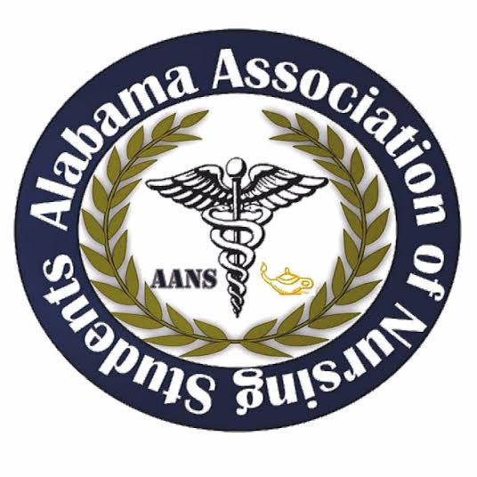

Alabama Association of Nursing Students
Executive Board Meeting, April 6th, 2018
Meeting at Gaylord Opryland Hotel and Resort

1. Call to Order: The monthly meeting of the Executive Board was called to order at 0925 by Jennifer Hernandez, President.

2. Roll Call: Called by Jennifer Hernandez, President

Those Present:
President – Jennifer Hernandez
Vice President - Carter McDonald
Secretary - Monica Hill
Treasurer - Rebecca Stillwell-Miller
Communications Director - Kiana Simmons
Director of North - Marissa Walker
Legislative Chair - Carl Dewayne Henderson Jr
Community Health Director - Chanita Dale

Those Absent:
Director of South - Emma D Goodwin
Breakthrough to Nursing Director - Khaleah Monger

Quorum: Jennifer Hernandez, President, declared a quorum present.

3. Minutes: The minutes from the March 10th, 2018 executive board minutes were distributed and read.

Motion: It was moved and seconded to accept the minutes of the March 10th, 2018 executive board meeting
Submitted by: Jennifer Hernandez, President. Seconded by: Carter McDonald, Vice President. No objections made. Action: Carried.

4. Report of the Treasurer: The report was given by Rebecca Stillwell-Miller and a written report was distributed and is attached to the minutes. Highlights of the report included:
- Account balances: Checking account $27,872.62; Savings account: none Reserve investment account: $10,000.
- There are no outstanding bills.
- The budget for this year $ 13,000.00

Motion: It was moved and seconded to accept the report of the treasurer.
Submitted by: Jennifer Hernandez. Seconded by: Marissa Walker, Director North. No objections made. Action: Carried.

5. Reports from officers and committee chairs:

- President – Jennifer Hernandez
  - Policies and procedures and contracts at transition meeting
  - NSNA cords for constituents and faculty
- Vice President - Carter McDonald
  - Attended COSP
  - Focus sessions for local chapters
- Secretary - Monica Hill
  - Treasurers from local chapters reporting the state level
- Treasurer - Rebecca Stillwell-Miller
  - Purchasing Quickbooks for accounting
- Communications Director - Kiana Simmons
  - Spoke with vendors – Vanderbuilt, NHC Care, UAB, Littmann, UAH
- Community Health Director - Chanita Dale
  - ATI, Picmonic Vendors
- Director of North - Marissa Walker
  - Collecting ANS advisors at each school
- Director of South - Emma D Goodwin
- Legislative Chair - Carl Dewayne Henderson Jr
  - Elsevier
- Breakthrough to Nursing Director - Khaleah Monger

6. Unfinished Business:
  - Bylaws need to be looked at to propose any changes to be submitted for voting at the House of Delegates
  - Discussion of lack of vendors for Leadership Summit
    - May need to decrease vendor price from $700 to $400 in order to secure vendors for annual conference

Motion: It was moved and seconded to change the vendor fees from $700 to $350.
Submitted by: Jennifer Hernandez. Seconded by: Monica Hill, Secretary. No objections made. Action: Carried.

  - Action was carried to change the price of AANS shirts from $20 to $15, that needs to be reflected on the website
- Discussion of increasing the price of annual tickets to include a price of a t-shirt first come first serve (sizes) for preordering
- Need to start formulating the awards that will be given at AANS Annual Convention and need to work with new board to have those ready at time of election
- Date of AANS Annual Convention to be changed to September 28th, 2018 at Shelton Community College

Motion: It was moved and seconded to have AANS Annual Convention on September 28th, 2018 at Shelton Community College.
Submitted by: Jennifer Hernandez. Seconded by: Chanita Dale, Community Health Director. No objections made. Action: Carried.

- All officers need to start creating a packet of information and projects accomplished to help create a foundation to pass to the new board members.
o Need an in-depth transition of officers
- AANS Annual Convention to consist of
  - Key note speaker
  - NCLEX review or Elsevier Game
  - Rachel for Be the Match
  - Tourniquet Application?
  - Information on how to run a local chapter and NSNA awards/constituency
  - Formal brunch and awards ceremony
  - Elections
  - House of Delegates
  - Transition of officers
- ASNA Faces – action was carried to attend FACES in Montgomery on April 17th
- Blast e-mail for recap of Leadership Summit, upcoming NSNA Convention, FACES, and date for AANS Annual Convention
- Need more metals for AANS board members

7. New Business:
- Resolutions Workshop at Annual – mock resolution
- Awards explained at transition meeting
- Keynote speaker for Annual
- Old board work on leadership summit with new board
- Prepare House of Delegates meeting
- Changing Bylaws by Annual

Motion: It was moved and seconded to begin drafting policies and procedures and contracts for board members transitioning into positions at the state annual election.
Submitted by: Jennifer Hernandez. Seconded by: Carl Dewayne Henderson Jr., Legislative Director. No objections made. Action: Carried.

- Community Health Project for Annual – Hudson Alpha?
- Need to recruit vendors at NSNA Convention for Annual Conference
- Plan tentative future meeting

8. Next Meeting: The next meeting TBA

9. Announcements: No announcements

10. Adjournment: Jennifer Hernandez, President, has declared the meeting of the executive board to be adjourned at 1027 and will reconvene TBA.

Jennifer Hernandez, President Monica Hill, Secretary
