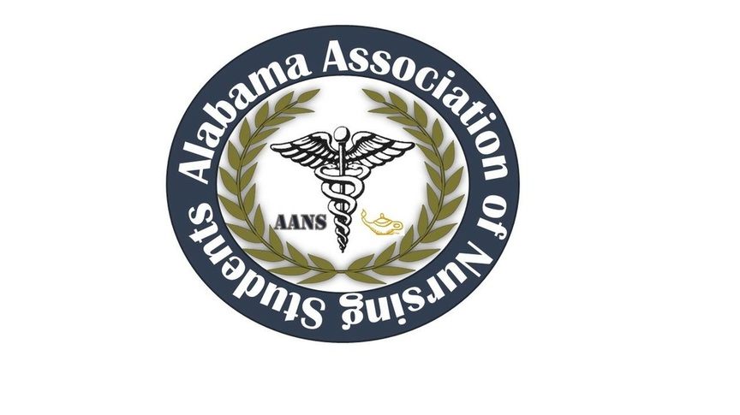
ALABAMA ASSOCIATION OF NURSING STUDENTS (AANS)
Executive Board Meeting-
– April 1st, 2016-
Call to order: Heather Burnette, President
The April 2016 meeting of the Alabama Association of Nursing Students was called to order on 4/1/2016 at 2046 by Heather Burnette, President.
Roll Call: Candice Sanders, Secretary 2046
- Heather Burnette, President
- Candice Sanders, Sectary
- Destiny LaBo, Treasurer
- Betsey Poole, Legislative Chair
- Amber Hood, Community Health Director
- Katie Kaye, Communications Director
- Ashlyn Sharp, Director North and South

Those found not to be in attendance were as follows:
- Emily Walters, Vice President
- Mark Reynolds, Faculty Advisor
- Colin Tomblin, State Consultant

Heather Burnette, President
State Convention
- Conference rooms for state convention have been booked for October 14th-October 15th. Conference is from October 13th-October 15th.
- Waiting to hear back from Josie for the 25-30 rooms blocked off in the Westin
- ASNA is paying for our conference rooms up front and we will find out if we will need to reimburse ASNA. Last year’s convention they did not have AANS pay for their rooms but will clarify at the next meeting.
- Events-ASNA has invited students and AANS to sever events. There will be a live auction on Friday night and Doctor’s Nassrres’ band will play after the live auction. This concert will be open to all nurses in Huntsville, AL. We do not have to financially contribute to the concert, but ASNA will have a table set up in the back that will be taking donations for the band. We are still in discussion on whether or not AANS will set up a table in the back. Students are welcome to this event as well; however, since there will be a bar at the concert, AANS officers will be in charge of making sure there is no underage drinking. We discussed checking licensures, having two different colored arm bands. Orange arm bands for under the age of 21 and green arm bands for over 21. We also discussed putting the students name on the armband. Board member may be able to drink one alcoholic drink but that would be the limit. ANA is still discussing whether they can have a scavenger hunt, the scavenger hunt would not be allowed at the Westin but around Bridgestreet instead.
- Events-During the conference, we discussed having a roundtable between AANS and ASNA. We will continue the round table for students to ask post graduates questions about preparing and taking the NCLEX, state licensures, and real life as a nurse. ASNA has also discussed starting a mentorship program to unite ASNA and AANS, details have not been discussed as of now.
- Vendors- There will be one form for vendors and there will be one flat price for all vendors. That price has not been finalized yet. The form will have both AANS’ and ASNA’ logo on the form. We will receive the funds from the student vendors and Heather will post the list for the vendors used in the past. Such as Hurst, ATI, Pharmacology made Insanely Easy, hospitals, and others.
- Speakers- As of right now we have two speakers and one vendor. Slyvia Rayfield from Pharmacology made Insanely Easy will be doing her session. Lynn Caffery will be speaking on Human Trafficking on Friday. The House of Delegates will be starting at 1430 and she will be speaking possibly before that. Sue is working towards making Lynn Caffery’s speak to count toward continuing education hours. David Spillers who is the CEO of Huntsville Hospital and is also the keynote speaker for ASNA will be speaking to AANS on Friday from 1100-1200.
- Events- Discussed possibly meet-n-greet to welcome students and be a visible face to them as they arrive to conference. Light snacks would be provided and we would ask during pre-registration or during a survey prior to conference, how many people would be interested and if the number is sufficient that we will proceed will this event. If we decide to move forward with this event and held the meet-n-greet at the Westin for approximately 75-100 people; snacks would have to be purchased through the Westin. If not held at the Westin we would be able to purchase our own snacks.
- ASNA has provided lunch for AANS members in the past. Will find out further details during the next meeting.
- Our biggest issue is going to be food; and during our leadership conference we received many positive compliments on the snacks provided.
- ASNA was asked to help us pay for at least a meal for the students. Will find out more information at the next meeting.

- Heather Burnette moved to repurchased the email blast. Ashlyn Sharp seconded the motion. No objections were made.

- Next meeting will not be until first of June.
Meeting adjourned at 2131.
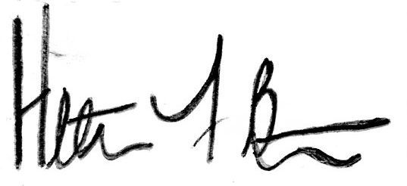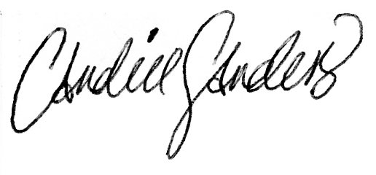
Heather Burnette, President Candice Sanders, Secretary

