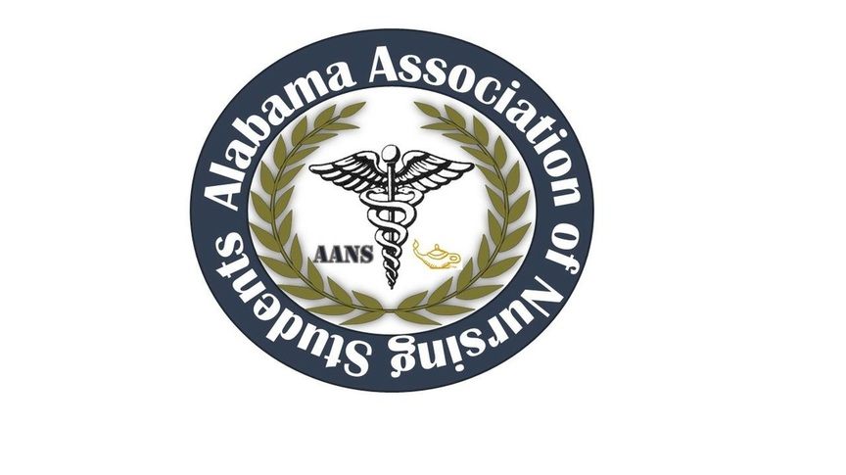
ALABAMA ASSOCIATION OF NURSING STUDENTS (AANS)
Prior to this meeting the following decisions were made through email communications:
11/15/15 1739 February 26th was voted to be the first choice date for the leadership summit at Shelton State Community College. March 2nd will be used as a reserve date.
Executive Board Meeting- Conference Call
– December 29th, 2015-
Call to order: Heather Burnette, President
The December 2015 meeting of the Alabama Association of Nursing Students was called to order on 12/29/2015 at 1803 by Heather Burnette, President.
Roll Call: Candice Sanders, Secretary 1804
- Heather Burnette, President
- Emily Walters, Vice President
- Candice Sanders, Sectary
- Betsey Poole, Legislative Chair
- Katie Brink, Community Health Director
- Katie Kaye, Communications Director
- Ashlyn Sharp, Director North
- Nicole McDougle, Director South
- Colin Tomblin, State Consultant

Those found not to be in attendance were as follows:
- Destiny LaBo, Treasurer
- Mark Reynolds, Faculty Advisor

Adoption of November minutes: Heather Burnette, President 1804
Heather Burnette moved to adopt the minutes. Emily Walters seconded the motion

Heather Burnette, President
- Leadership Summit- “Nurses Lead by Example” Friday, February 26th, 2016 is the first choice and currently waiting on confirmation. Friday, March 4th, 2016 will be the reserve date if unable to use the first choice.
- Speakers from surrounding colleges and/or hospitals including but not limited to: charge nurses, nurse managers, and nurse educators.
- Two confirmed speakers from Shelton State
  - Mrs. Andrea Bowden Evans speaking on Ethics in Nursing
  - Dr. Rosalynde Peterson topic TBA
- Other possible speakers
  - Mr. Reynolds, if available, speaking on “Transforming Nexters Into Leaders ”
  - Brian Buchanan- ASNA President and/or Rebecca Huie
  - Rachel Harris with “Be the Match”
- Email blast once the date is finalized. Cost of Email blast is approximately $100 a year and will possibly need to be renewed.
- 1830 Heather Burnette moved to keep the registration price the same as last year and to purchase Chick Fli A for lunch. Katie Kaye seconded the motion. All were in favor of the motion.
- Registration will be online through Eventbrite and will be $35 per person and $32 per person with a group of 10 or more.
- A Chick Fli A lunch was the cheapest lunch and is costing roughly $5.79 per box which will include a chicken sandwich, chips, and cookie. We will purchase drinks from Sam’s.
- 1842 Heather Burnette moved to set the vendor pricing at $100. Emily Walters seconded the motion. All were in favor of the motion.
- Fundraiser Table- Older AANS shirts and possible new t shirt design. Alabama state outline on the back of the shirt with a stethoscope wrapped around the state. One solid color, no pocket will send out a survey monkey to decide on details.
- 1851 Heather Burnette moved to charge every fundraising table a cost of $25 per school for a table. Emily Walters seconded the motion. All were in favor of this motion. Shelton State Community College will not be charged this fee since they are hosting the event.
Vice President, Emily Walters
- Polos and badges for Conferences and meetings to stand out during events. These will be paid personally.
Communications Director, Katie Kaye
- If you still have not turned in your bio please do so ASAP.
Community Health Director, Kate Brink
- Currently in touch with Rachael Harris with “Be the Match.”
- January club meeting at UA.
Legislative Chair, Betsey Poole
- Wednesday, February 10th, 2016 rally at noon at the State Capitol. January 22nd is the next meeting.

NSNA Annual Convention is March 30th through April 3rd, 2016 in Orlando, FL- Disney’s Coronado Springs Resort. Flying will cost about $350 per ticket so looking further into driving and car pooling. $195+ tax a night for four people to a room. Deadline is March 14th and registration is online.
Heather Burnette adjured the meeting at 1920

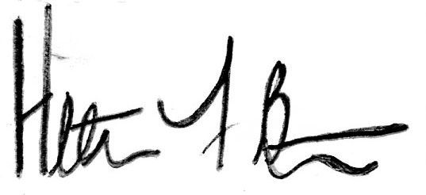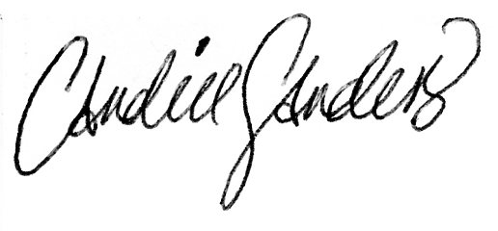
Heather Burnette, President Candice Sanders, Secretary

