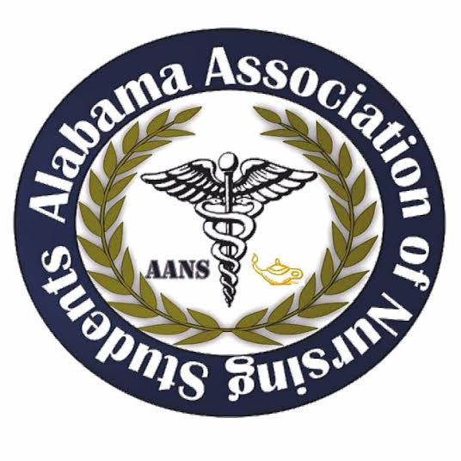
Alabama Association of Nursing Students
Executive Board Meeting, February 26, 2017
Conference Call 1930

- Call to Order at 1943: Emily Walters, President
- Roll Call: Lorena Cruz, Secretary
  - All members found in attendance expect for Lindsey Gusich, Frederick Richardson, and Betsy Poole. Quorum called at 1943 with 7 out of 10 members present.
- Adoption of January minutes: Emily Walters, President
  - Adoption of January 2017 meeting minutes motioned by Emily Walters, President at 1944. Kristina Faw, Vice president, seconds the motion. No objections made.
- Shelton table vote: Emily Walters, President
  - Voted for the set up of a Shelton table at the leadership conference by Emily Walters, President at 2010. Kristina Faw, Vice President, seconds the motion. No objections Made.

Emily Walters, President

- Leadership Summit Speakers
  - Donna Guerra (Need Speaker Form)
  - Ben Floyd- Kaplan
  - Rachel Harris- Be The Match
  - Amy Woodward- Alabama Organ Center
  - Lindsey Harris- CRNP (Need Speaker Form)
  - DCH Nursing Director (Need Speaker Form)
  - Possible CRNA (Need Speaker Form)
  - Rebecca Huie- ASNA President
- Vendors
  - Be The Match
  - Alabama Organ Center
  - DCH Medical Center
  - University of Alabama Huntsville
  - Brookwood Medical Center
  - Kaplan NCLEX Review
  - Generally every year we have let the host school set up a vendor table (VOTE)
  - University of North Alabama is a recommendation from Kari
- Schedule for the day
  - Everyone PLEASE arrive by 7:30
  - I would love if everyone that lives near Tuscaloosa can get there before 7:30 (possibly 7am) to help set up)
  - I will bring muffins and we will have coffee, water set up for board members for breakfast
  - We will have lunch around 12 or 12:30 and will last 45 minutes or an hour (depending on how much time we will have for the day)
  - The conference should be done around 2:30 or 3. Kaplan will finish out the conference with their review.
  - There will be 2 or 3 scheduled 10-minute breaks.
  - We will have 2 scheduled 10 minute breaks during the NCLEX review.
- Costs for AANS
  - I will go to Sam’s Club the night before to get snacks (Vote on a budget)
  - Lunch for vendors/speakers will be provided
    - (A SurveyMonkey will be sent prior to ordering)
    - These are some of the options for catering:
      - Olive Garden
      - Dickeys
      - McAllister’s
      - Publix
  - Kaplan is PROVIDING lunch for students. No charge for AANS.
  - Polo’s have been ordered (Silent vote through SurveyMonkey on 2/16/17)
  - Name Badges are being ordered (Silent vote through SurveyMonkey on 2/16/17)
- Ticket Sales
  - Ticket sales have been really slow. This generally happens and students tend to order tickets the very last minute. Just keep promoting.

- Kristina Faw, Vice President
  - Are t-shirts going to be given there?
    - T-shirts are going to be set up at the conference
  - Are there going to be any giveaways?
    - There will be giveaways, such as t-shirts or etc.
  - What is the attire for the board members?
    - A red polo with dark jeans and your own choice of shoes.
- Lorena Cruz, Secretary
  - No questions
- Frederick Richardson, Communications Director
  - Not present
- Anna Katherine Curlee, Director North
  - She will contact the CRNA
  - She has sold 3 shirts so far.
- Kari Battocletti, Director South
  - When will bags be prepared?
    - They’re already packed.
- Brittany Elike, Community Health Director
  - No questions
- Donna Guerra, Faculty Director
  - No questions

- NSNA Conference April 5-9
  - What are school’s paying for?
    - UAH (conference and hotel), UNA , Shelton
    - People who are going: Emily, Brittany, Betsy, Kristina, and Fredrick. (maybe Lindsey)
    - Once we have this information set in stone we will schedule a meeting to go ahead and develop a budget
  - Right now we are looking at plane tickets, hotel (may end up staying at hotel nearby and using an Uber to get over to Convention Center- only like $6-10 a ride- $2-4 a person), and food budget for each person.
  - May only go for half the conference. This will be discussed at the next meeting AFTER the Leadership Summit

Meeting adjourned at 2017 by Emily Walters, President.

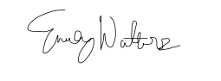
Emily Walters, President Lorena Cruz, Secretary
