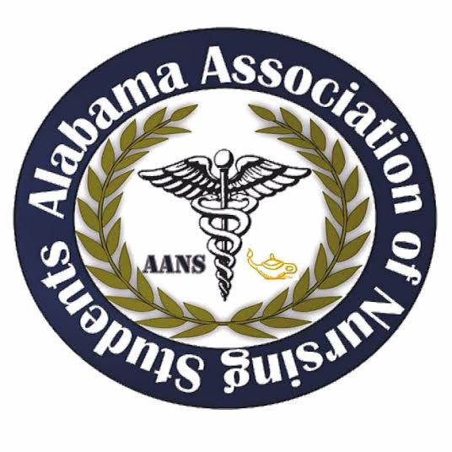
Alabama Association of Nursing Students
Executive Board Meeting, March 27, 2017
Conference Call 1930

- Call to Order at 1936: Emily Walters, President
- Roll Call: Lorena Cruz, Secretary
  - All members found in attendance expect for Anna Katherine Curlee, Director North. Quorum called at 1937 with 9 out of 10 members present.
- Vote for paying meals for members, Fredrick Richardson and Kristina Faw, who are attended national conference by Emily Walters, Present at 1958. Lindsey Gusich, Treasurer, seconds the motion. No objections made.

Emily Walters, President

- Kristina Faw, Vice President
- Lorena Cruz, Secretary
- Frederick Richardson, Communications Director
- Anna Katherine Curlee, Director North
- Kari Battocletti, Director South
- Brittany Elike, Community Health Director
- Donna Guerra, Faculty Director

Meeting adjourned at 2001 by Emily Walters, President.

Emily Walters, President Lorena Cruz, Secretary
