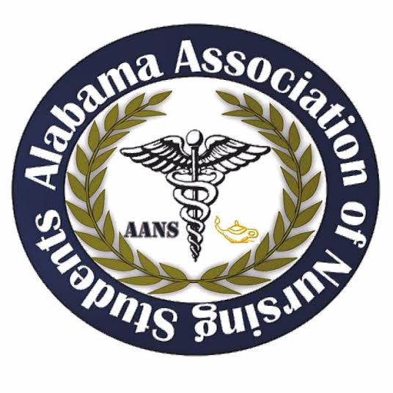
Alabama Association of Nursing Students
May 26, 2017
Conference Call 1900

Call to Order 1905: Emily Walters, President

Roll Call: Lorena Cruz, Secretary
All members found in attendance. Quorum called at 1906 with 11 out of 11 members present.

Emily Walters, President

- Leadership Summit
  - Huge success
  - Lots of great feedback
  - Speakers, vendors would like to be in attendance at the next conference
- October Conference
  - October 6-7 (Friday and Saturday)
  - Hoover, AL
  - Officer’s will generally arrive Thursday night and leave Saturday afternoon after the transition meeting with the new board.
  - This conference is in conjunction with ASNA
  - We need to have a count of who is planning on reserving a room for the conference.
- General details to discuss:
  - Friday is the general conference
  - Saturday we will have a speaker or two, a Q&A with the officers (us), and then the House of Delegates meeting where we vote on the new board.
  - ASNA has stated that the theme of their conference is the healthy nurse. We will have the same theme.
  - Our goal is to make this conference FUN for our students!
  - ASNA is hosting an auction. Last year AANS contributed a basket.
  - Friday night ASNA is having a DJ and karaoke. All students are invited!
    - I am going to try and find a way to have students RSVP to this event when they register for the conference on Eventbrite.
- ASNA has generously asked Alacare to include us in the conference bag donation! We will be asking speakers/vendors for donations as well to give to our students/raffle off.
- May look for an organization in Hoover to donate for the conference
- Brittany will be in contact with everyone about the conference via email and Facebook.
- Service project – Jeanette will be in contact with Brittany about the ASNA service project.
- There will possibly be a play on Domestic Violence Friday that would be in conjunction with ASNA.
- UAB has a grant to demonstrate PPE donning/removing. Are we interested in doing this for the conference?
- Funding the conference
  - Last year ASNA provided the funding for our conference. AANS paid for drinks for the attendees, as well as the officer’s expenses.
  - Vendor money! We have specific vendor forms I will send to each of you. Ask around such as; Universities, publishing companies, health organizations, etc. We MUST use these vendor forms since they have our logo at the top.
    - This year we will send the vendor form to whom ever is over ASNA, Charlene
    - Make sure the form has the logo at the top!
- What do WE need to do???
  - Vendors!
    - We will not contact vendors until we find out more about the conference funding.
  - Speakers! Holding off on getting a lot of speakers until I find out more about the Domestic Violence play and the UAB PPE.
  - Make sure your schedules are clear to attend this conference. It is very important, as we will be transitioning to a new board!
  - Awards
    - We will start setting up the packets to apply for awards. This will be sent our via email or Facebook
  - Officer pre-slate applications:
    - Make sure to get schools in the area involved.
    - For a person to receive a position on state board, it is not mandatory to fill our application. However, if there is only a single person that fills out an application, and is turned in before the due date, for the president position ONLY, no one else can be nominated by the floor. This is guaranteed position for this person only. Everyone else that runs for office (ex. secretary, treasurer, etc.) is not guaranteed a position for state board.
    - Make sure that the applicants have delegated to vote for them if they are running for a position.
    - Delegate can only be an ASNA member; these members will be approved before they are allowed to enter the room to vote.
    - If you want the same position then preslate for the position

- Kristina Faw, Vice President
  - She will be in contact with Emily about the ASNA service project
- Lorena Cruz, Secretary
  - No comment
- Lindsey Gusich, Treasurer
  - No comment
- Frederick Richardson, Communications Director
  - Frederick mentioned about contacting several schools about getting involved with the state chapter.
- Brittany Elike, Community Health Director
  - No comment
- Kari Batocletti, Director South
- No comment
- Anna Katherine Curlee, Director North
  - No comment
- Betsey Poole, Legislative Director
  - No comment
- Donna Guerra, Faculty Advisor
  - No comment
- Jeanette Atkinson, ASNA Liaison
  - Jeanette mentioned that every ASNA should opt to donate a basket to raffle off. There are 5 districts.
  - Mentioned to promote the scholarships that are offered for those involved in leadership.

Meeting adjourned 2011

Emily Walters, President Lorena Cruz, Secretary
