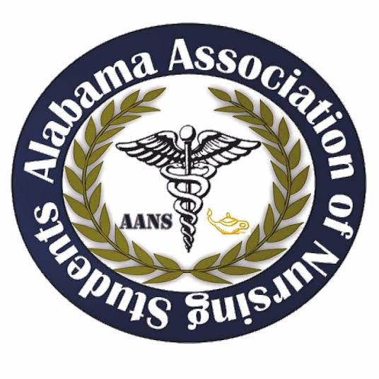
Alabama Association of Nursing Students
Executive Board Meeting, January 15, 2017
Conference Call

Call to Order 1902: Emily Walters, President

Roll Call: Lorena Cruz, Secretary
All members found in attendance except for Betsy Poole, Legislative Chair. Quorum called at 1903 with 8 out of 9 members present.

Adoption of November 2016 meeting minutes motioned by Emily Walters, President at 1903. Anna Katherine Curlee, Director North seconds the motion. No objections made.

President – Emily Walters
- Ticket Sales
- Eventbrite is live
- PROMOTE PROMOTE PROMOTE ANS leadership summit
  - Promote on Facebook this week
  - Groupme
- Ticket contest
  - If someone shares or comments on a Facebook post
- Speakers
- Letters need to be sent out to potential speakers. (Nurse managers, Nurse Practitioners, Clinical Educators, etc) Opportunities in Nursing!
- Rachel Harris with Be the Match will generally speak
- I will send a letter out to Rebecca the ASNA president
- Donna will speak
- Possible presentation with or Hurst or Kaplan
- Will do a NCLEX review
- Speaker letters with return presentation sheets
  - Letter are for those who think they know someone that will be a good fit for this conference to speak at
  - Contact Emily Walters
  - Make sure you get all the info so we can set the agenda
- Vendors
- Everyone has the vendor letters as well as the registration form
- Universities, hospitals, testing resources
  - UNF
  - UAB
  - Saint Vincent
  - We usually have a 4-5 speakers (not including the review and vendors)
- Fundraising
- We will have our T-shirts available for purchase at the conference!
  - They are also being sold at UAH and UNA
  - Will probably doing door prizes such as shirts, gift card ($25) for a scrubs store, and/or a Kaplan review.
- Attire
- Do we want to have a Polo shirt? Pants? Name tags?
  - Navy short sleeve polo
- Getting the word out
- Facebook! Post updates regularly about the leadership summit!
- Promote event to the cohorts at your local school
- Email blast about summit, once we get everything finalized
- Director North/South gather schools around Tuscaloosa and we will come up with a personal email to send each of their advisors and/or chapter presidents
  - UA
- Agenda
- Speakers are needed to be registered by March 1, so agenda can be made and sent out to speakers
- Tri-fold agendas with timeline and information to be made for speakers and attendees
- Breaks
- Water pitchers
- Snacks?
  - Sams club (granola bars, etc.)
- Lunch- Chick fil a?
- Advertisement
- Signs inside
- Driveway signs
- Shelton State Ambassadors will be there to direct
Vice President- Kristina Faw
- Vendor and speaker ideas
  - Rachel Harris with Be the Match
  - Tennessee Chattanooga CRNA that was at the state conference, interested in contacting her to be a vendor
  - Contact a vendor for air force nursing
  - Travel nursing vendor/speaker?
  - Contact speakers to represent UAB or from Huntsville Hospital
Secretary- Lorena Cruz
- No questions
Treasurer- Lindsey Gusich
- No questions
Communications Director- Fred Richardson
- Has updated the website talking about the leadership summit
Community Health Director- Brittany Elike
- No questions
Director North – Anna Katherine Curlee
- No questions
Director South – Kari Battocletti
- Speaker ideas
  - Nurse practitioner speaker
  - Travel nursing speaker
Legislative Chair – Betsey Poole
- Not present

New information:
- Next meeting needs to be 1-2 weeks (end of February to the first week of March) before Summit to finalize any small details and coordinate times

Meeting Adjournment at 1959 by Emily Walters, President

Extra information
- Donna Guerra
  - Awards available for NSNA
  - Has connections to nurse practitioners

Emily Walters, President Lorena Cruz, Secretary
