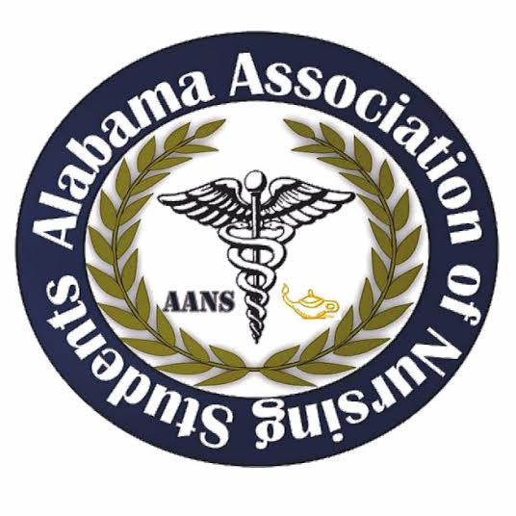
Alabama Association of Nursing Students
June 23, 2017
Conference Call 1950
Call to Order at 1950: Emily Walters, President

Roll Call: Lorena Cruz, Secretary
Quorum called at 1950 with 9 out of 11 members present. Brittany Elike, Community Health Director, and Kari Battocletti, Director South, were not present.

Adoption of February 2017 meeting minutes motioned by Emily Walters, President at 1952. Kristina Faw, Vice President, seconds the motion. No objections made.

Adoption of March 2017 meeting minutes motioned by Emily Walters, President at 1952. Frederick Richardson, communications director, seconds the motion. No objections made.

Adoption of May 2017 meeting minutes motioned by Emily Walters, President at 1952. Kristina Faw, Vice President, seconds the motion. No objections made.

Emily Walters, President

- October Conference
  - We are officially holding the conference on October 6-7 (Friday and Saturday)
  - Location: Hoover, AL
  - Officer’s will generally arrive Thursday night and leave Saturday afternoon after the transition meeting with the new board.
  - In conjunction with ASNA
  - Need to go ahead and make room reservations
    - $130 per night/per room
    - Who can NOT attend?
      - Lindsey Gusich
- General planning details to discuss:
  - We have been asked to participate in a leadership workshop/domestic violence lecture as well as ASNA’s keynote lecture. This is great!!
  - Heather Burnette (past President) has offered to speak about L&D nursing, etc.
  - We always try and get the ASNA President (Rebecca Huie) to speak about ASNA and leadership in nursing. Generally on Saturday before our HOD meeting.
  - I would love to get someone to come speak about healthy eating, stress reduction, etc. After all we are going to try and go with the theme “The Healthy Nurse.” Ideas????
  - If you have any ideas for potential speaker let me know! We want this to be a fun AND educational conference.
  - I will go ahead and contact Kaplan about possibly doing another NCLEX review!
  - Also, I have received the contact information for the UAB woman conducting the PPE class and will try and see if they can come on Friday!
    - We talked about not doing the whole 5 hours, but instead cutting it in half.
  - Service Project ideas??
    - This is important to have by __ because there is an award for this and we need to give enough time to apply.
  - NSNA will have 2 lectures
- Night Activities
  - ASNA is hosting an auction. Last year AANS contributed a basket.
    - Theme idea: healthy nursing basket with fitness or health goodies.
  - Friday night ASNA is having a DJ and karaoke. Students invited!
    - I am going to try and find a way to have students RSVP to this event when they register for the conference on Eventbrite.
- Funding the conference
  - Vendor money! We have specific vendor forms I have sent to each of you as well as a vendor letter. Make sure when you contact a vendor you attach BOTH attachments to the email. Ask around!! Universities, publishing companies, health organizations, etc. We MUST use these vendor forms since they have our organization at the top.
    - So far we have received $650 from Hurst Review
    - Already confirmed vendors (Do NOT contact these vendors): DCH, Jackson Hospital, Troy University.
    - I am going to contact the vendors that were present at Leadership Summit.
    - Please let Emily Walters know if you are planning on contacting a vendor.
- $700 per vendor is A LOT of money so lets get these vendors in! Also, there is a spot on the vendor form I have sent to you all that gives them the option to provide a donation if they cannot be in attendance.
- Our room that we are reserving is $500 per day ($1000 for Friday and Saturday) I am going to see if there is any way we could possibly open up the room Thursday night just to get things set up. (Will have this answer by our next meeting in August)
- Next meeting we will discuss the Eventbrite price and will begin selling tickets in August!
- What do WE need to do???
  - Vendors!
  - Speakers- let me know if you have any ideas for speakers before contacting them. I want to get a rough draft of our schedule set up first to see how many speaker slots we have open.
  - Awards and officer pre-slate applications I want to get up and running by August 15th and make the deadline around September 20th.
    - Promote pre-slate on facebook
  - Everyone will have a responsibility for this conference
    - Fred: Let’s promote this conference like never before! Make a post about each speaker! I will send you all the info for the speakers/lectures that we will have as they get confirmed.
    - Lindsey: We will go ahead and start a budget and working out all the money funding details.
    - Brittany: Service project?? Inform Be The Match about the conference to see if she can attend.
    - Kari and Anna Katherine: promote promote promote. If you have the contacts for any schools, promote the conference! Make sure they know! (Fred and Kristina said they have some various schools that did not even know we had a student organization. Get with them and lets get info out to these schools)
    - Betsey: You know what you have to do as far as all the delegate information goes!
    - Lorena: When we get the awards and the pre-slate information set up I will send you information about creating slideshows for the conference.
    - Kristina: We will work together on getting the schedule set up, vendor information sent out, and the little details of the conference
- I am SO excited about this conference and this is when we really all need to work together as a board to make sure this conference goes smoothly. This is a much larger conference than the Leadership Summit!

- Kristina Faw, Vice President
  - Vendor idea: University of Tennessee Chattanooga nurse anesthetist
- Lorena Cruz, Secretary
  - Where is the conference? Embassy suite
- Lindsey Gusich, Treasurer
  - No comment
- Frederick Richardson, Communications Director
  - Send Fred pieces of information such as speakers to keep the public updated about the conference.
- Brittany Elike, Community Health Director
  - Not present
- Kari Batocletti, Director South
  - Not present
- Anna Katherine Curlee, Director North
  - No comment
- Betsey Poole, Legislative Director
  - No comment
- Donna Guerra, Faculty Advisor
  - Commented that she thinks we are doing a great job on this state conference.
- Jeanette Atkinson, ASNA Liaison
  - Talk to nursing schools about promoting conference by getting the schools posters for the school and for any social media.

Meeting adjourned at 2036

Emily Walters, President Lorena Cruz, Secretary

