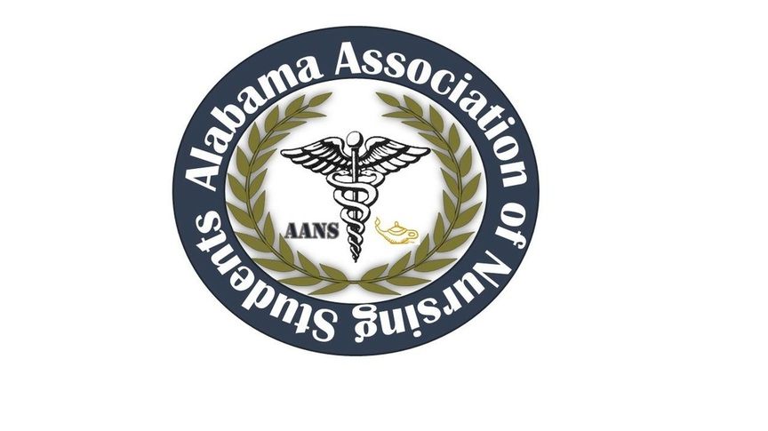
ALABAMA ASSOCIATION OF NURSING STUDENTS (AANS)
Prior to first meeting the following decisions were made through email communications:
10/12/15 1222 Heather Burnette moved to vote Katie Kaye into Communications Director by non-secret ballot via email communications
10/12/15 1939 Katie Kaye was voted into Communications Director via email communications
10/18/15 1308 Heather Burnette moved to vote Nicole McDougle into new Director South by non-secret ballot via email communications
10/19/15 1324 Nicole McDougle was voted into Director South
Executive Board Meeting- AVE Apartment Conference Room, Tuscaloosa, Alabama
– November 1, 2015-
Call to order: Heather Burnette, President
The October 2015 meeting of the Alabama Association of Nursing Students was called to order on 11/1/2015 at 1316 by Heather Burnette, President.

Roll Call: Candice Sanders, Secretary 1317
- Heather Burnette, President
- Emily Walters, Vice President
- Candice Sanders, Sectary
- Destiny LaBo, Treasurer
- Betsey Poole, Legislative Chair
- Katie Kaye, Communications Director
Those found not to be in attendance were as follows:
- Katie Brink, Community Health Director
- Nicole McDougle, Director South
- Mark Reynolds, Faculty Advisor
- Colin Tomblin, State Consultant

Adoption of October minutes: Heather Burnette, President 1318
Heather Burnette moved to adopt the minutes. Destiny Labo seconded the motion
Introduction and voting of new board member, Director North
Heather Burnette moved to vote in Ashlyn Sharp by non secret vote at 1319.
Candice Sanders seconded the motion
All were in favor of this motion

Heather Burnette, President
- Survey Monkeys: Everyone was very timely on responding to this survey
- Heather Burnette addressed an issue to response to emails, text, survey monkey within 24-48 hours as an expectation.
- For officer reports Heather only received 2 out of 9 reports on time. Please be timely with your reports, if you have nothing new then report back to Heather with an email that you do not have any new news or updates.
- Questions/answers about the officer report. There were no questions addressed.
- NSNA Midyear Convention- At the convention they teach you how to run your position for state. How to get promotions out there and how to interact with NSNA. Depending on the budget from Destiny we will be able to see how many people we can send. Bone Marrow vendor will be there, you will be able to receive a certification for American Red Cross Disaster Relief it’s a lot like national convention.
- November 5-8, Atlanta, GA and Registration - $85
- Hotel and Fees-Different hotels could be an option
- We decided that we would not send anyone to attend convention.
- Leadership Summit Heather and other Shelton State members talked to the Dean and we can get the building for free if we host the event on a Friday. What audience are we targeting? High School students vs nursing schools. Saturday we would have to hire a clean up crew and security. Dates are an issue: ACT testing, and spring break will be issues that we will have to address. Second week of March is when Alabama school’s start spring Break. Dates we are currently looking at are as follows: Feb 19th, 26th or March 4th. (All Fridays)
- Last year individual’s prices were $30 and $25 for group more then 10.
- Heather Burnette moved to vote to have the leadership conference at Shelton State and on a Friday at 1356. Candice Sanders seconded the motion. The vote was unanimous in her favor
We decided to keep the same theme as last year: “Nurses Lead by Example”
Objectives: Ethics, Community Service Project
- Scholarship(s)? If we can’t find a donation to provide a scholarship, we decided to give away two free trips to Leadership Summit via likes and shares on FB.
- Speakers and professors from various universities/colleges
- State projects- Will have to wait on Katie Brinks to decide
- Registration has been decided to wait til the next meeting when we find out how much Chick Fil A will charge for the meals. Pepsi hopefully will be donated and the chips and cookies will be bought from Sam’s.
- Leadership Certificates for attendance
- Vendors are an option to put them in the gym
- Giveaways? Hurst bags and add in the agenda for the day

- Nurses Day at the Capital
- February 10, 2016 – Montgomery, AL. Heather and Betsey will give a speech and will decide what to speak on when the time comes.

- FACES ‘16
- April 12, 2016
- NSNA Annual Convention
- April 2016 – Orlando, FL
- Fundraising
- T-shirts – the back design can be the outline of the state of Alabama.
- By the next meeting we can have a t-shirt design, prices, and who to use as the company.

Emily Walters, Vice President
- Polos for Conferences and meetings to stand out during events. These will be paid personally. The personal decision of AANS, name, and position being monogrammed onto the polo.
- Leadership Summit
- Hands on activities

Destiny LaBo, Treasurer
- We currently have a budget of $15,700, further discussion on whether convention has already been paid for.
Betsey Poole, Legislative Chair
- Attending Alabama Coalition of Nursing Organizations Meeting
- Betsey will be attending the meeting and will report back with details.
- Thursday, November 5, 2015 – Montgomery, AL
We decided that no one would be able to attend midyear convention due to time restraints.
We planned for our next meeting to be the first week of December via conference call.
Heather Burnette adjured the meeting at 1525

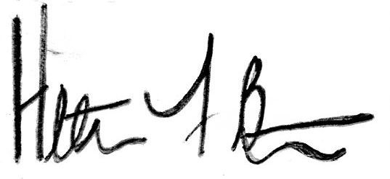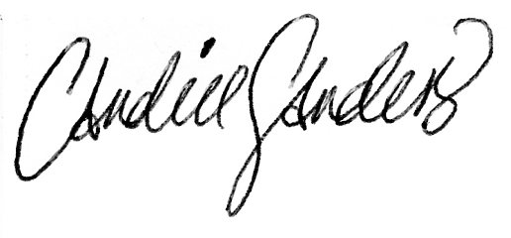
Heather Burnette, President Candice Sanders, Secretary

