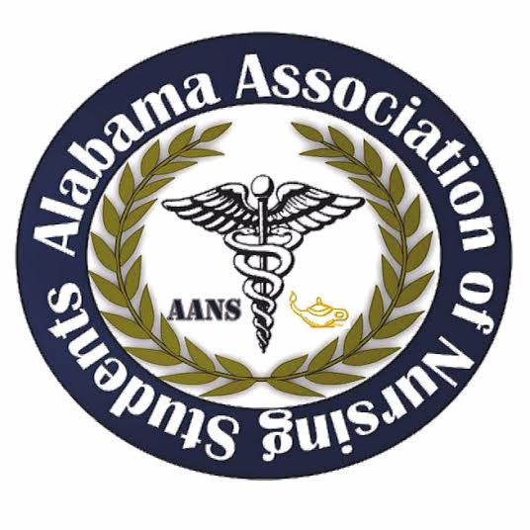
Alabama Association of Nursing Students
September 3, 2017
Conference Call 1900
- Call to Order at 1906: Emily Walters, President
- Roll Call: Lorena Cruz, Secretary
  - Quorum called at 1907 with 8 out of 10 members present. Those not present include Betsey Poole, Legislative Chair and Jeanette Atkinson, ASNA liaison.

Emily Walters, President
- Take a look at the tentative schedule and let me know what you think.
  - We will more than likely be sitting in on ASNA’s Leadership Academy as well as Judge Sue Bell Cobb’s presentation
  - Explanation of each one
- Eventbrite is live. SHARE SHARE SHARE
- Award packet and preslate packets are complete! Make sure your schools have them and send them out to other schools. Continually promote these two things!
- Budget:
  - Meals
    - Lunch and dinner on Friday – this is for 7 people
      - Voted on $15 for lunch per person, motioned by Emily Walters, President at 1952. Kristina Faw, seconds the motion. No objections made.
    - $25 on dinner
      - Voted on $25 for dinner per person, motioned by Emily Walters, President at 1952, Kristina Faw, seconds the motion. No objections made.
- Travel
- Gas money?
- Plane ticket
  - Will do a survey monkey on this.
- Hotel
- 3 hotel rooms, 2 nights- $889.20
- Conference room, 2 days - $500 per day and water is free
- What everyone needs to know/be aware of:
  - If you are staying in the hotel I suggest arriving on Thursday afternoon/evening.
  - We will check out the conference room and set everything up that needs to be set up the night before.
  - Friday morning everyone needs to arrive at the hotel/be in the conference room by 7am on Friday.
  - Following the conference we will all have dinner together and then there is a DJ/Karaoke event with ASNA.
  - Saturday we will all need to be in the conference room by 7:30. Please try to be there on time!
  - The HOD meeting/Election of officers generally lasts about an hour and a half.
  - Following this we will go out to lunch with the new officers.
  - I need everyone to change the password to your gmail account to __________ and WRITE IT DOWN.
    - Also write down your email address.
  - Write up a paragraph of your duties and sort of a welcome to the AANS Executive board. You can give them your contact info as well in case they have any questions throughout the beginning of their term.
  - Both days everyone will need to wear business casual attire. No T-shirts, sneakers, flip flops, etc.
  - Whoever has T-Shirts and boxes of AANS stuff, bring them to conference!! Make sure to announce that we are going to be selling T-shirts at the conference!
  - All of the proceeds collected from the live auction items that we donate go to US! According to John Zeigler. If anyone knows any local businesses (spas, restaurants, etc), ask them if they would like to make a donation! We have letters you can give them when you ask for a donation.

- Frederick Richardson, Communications Director
  - Continue to promote on Facebook and post links to the website, along with the awards application and pre slate packet. Use the email blast as well!

- Kristina Faw, Vice President
  - Create a tri-fold for the conference with the schedule. I will send you an example of what we did in the past.
  - Type up a budget. I will send you an example of that as well!

- Lorena Cruz, Secretary
  - Create a slideshow for the Awards Ceremony and the pre-slated nominees. Have a picture of election of officers & a small biography while they are speaking. Also haveslides with the picture of people who will win an award. Have it done by the 5th.

- Anna Katherine Curlee, Director North
  - Send copies of the awards packet and pre-slate applications to the schools in your area. Make sure they know that every school has an opportunity to win an award and they can have someone from their school be pre-slated for a state position!

- Kari Battocletti, Director South
  - Send copies of the awards packet and pre-slate applications to the schools in your area. Make sure they know that every school has an opportunity to win an award and they can have someone from their school be pre-slated for a state position!

- Betsey Poole, Legislative Director
  - Get the list of schools for the delegate registration table.

- Brittany Elike, Community Health Director
  - Look up places taking donations for people affected by hurricane Harvey, along with what they are accepting. We will be typing up cards and putting them in everyone’s bags.

- QUESTIONS/COMMENTS
  - Question: Will Kari and Anna Katherine will be the only ones who are going to be contacting school? stick with the contact list that was sent.
  - If you have contacted a school please update the excel document.

Meeting adjourned at 2007

Emily Walters, President Lorena Cruz, Secretary
